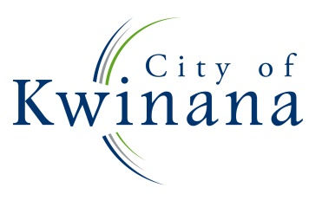
PUBLIC NOTICE

CITY OF KWINANA

ELECTORS’ GENERAL MEETING

The Electors’ General Meeting for the City of Kwinana will be held on Wednesday 31 January 2023 commencing at 5:30pm at the City of Kwinana Council Chambers, located at the Administration Centre on the corner of Gilmore Avenue and Sulphur Road, Kwinana.

The purpose of this meeting is to receive the Annual Report for the previous financial year and present a report from the Mayor and the Chief Executive Officer.

Copies of the 2022/2023 Annual Report, including financial statements, will be made available online at www.kwinana.wa.gov.au and in hard copy at the City of Kwinana Administration Centre and the City of Kwinana Library.

Wayne Jack
Chief Executive Officer

